In JAVA

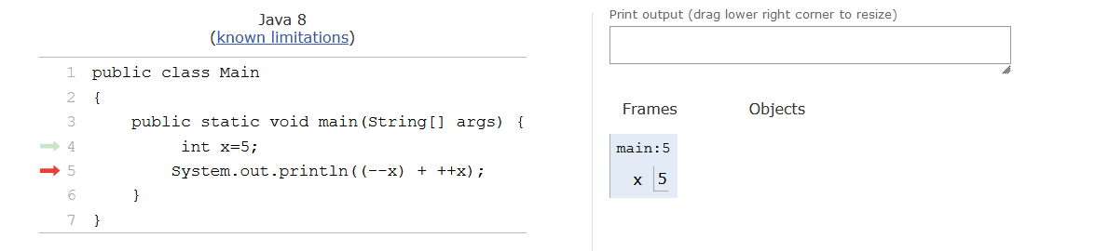

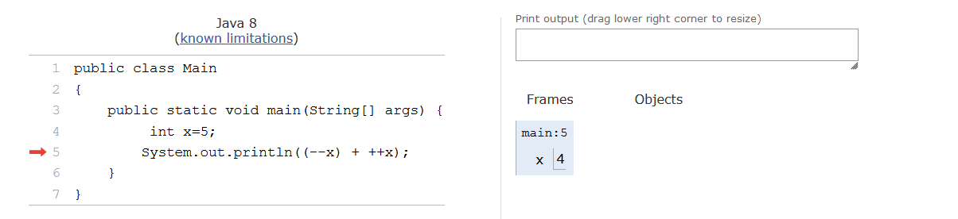

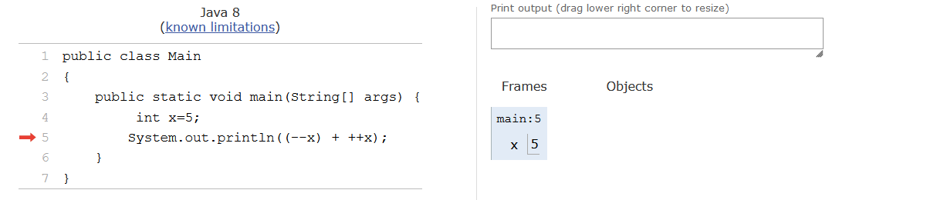

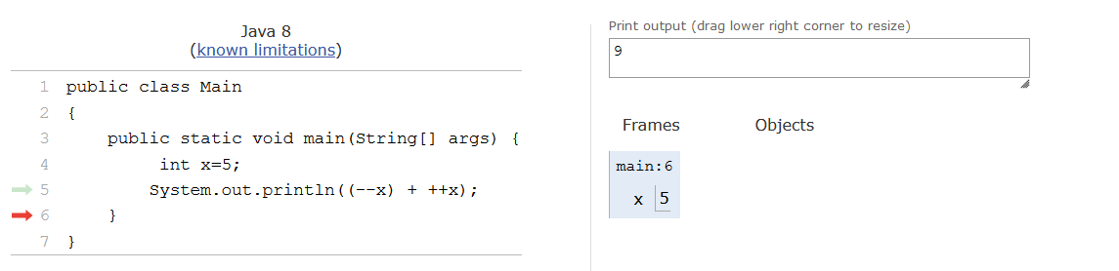

For each and every time, pre-increment and post-increment will change the actual variable values in the memory

In C

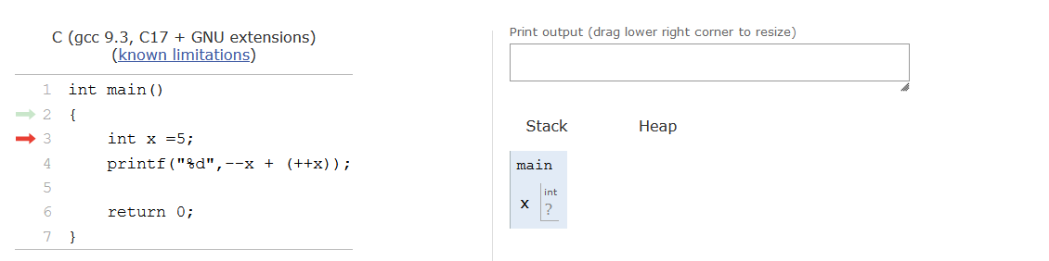

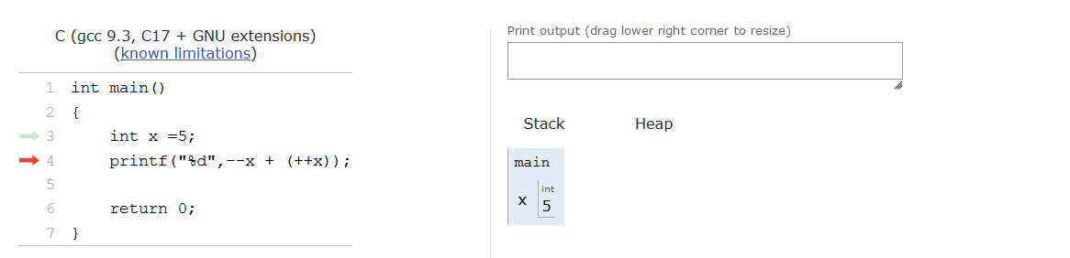

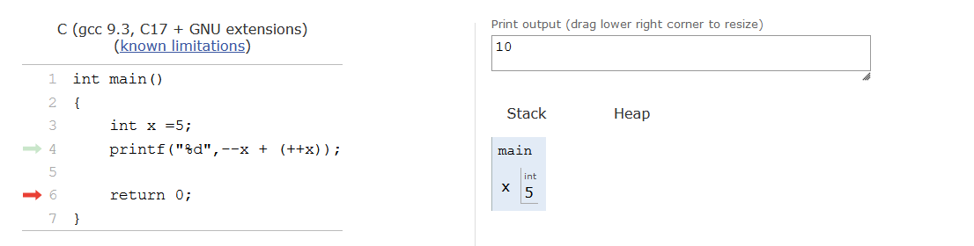

Here the actual variable is not-at all changed.